**Yom Kippur by Rabbi A.Z. Saunders**

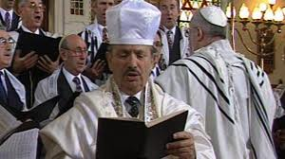

***What is Yom Kippur?***

*The 10th  of Tishrei in the year 2448 was the day G-d finally forgave the Jews for serving the Golden Calf. G-d therefore chose this day to annually forgive the Jews from their sins as long as they repented. This means that we can break up our lives into small sections called years. If there was no Yom Kippur we would go on sinning with no natural break. Our lives would be one long block of sins. We are fortunate however, that G-d has given us the opportunity to examine our deeds and repent for our sins.*

*In the Neilah prayers we take this a stage further and thank G-d for giving us this day: “In order stop our treachery.” We can understand this quite simply. People get frightened when the High Holy Days approach. People might be scared about what may be written down for them for the coming year. This brings about repentance. Even if people return to their sinful ways after the High Holy Days at least they have broken the cycle and achieved something. A good example of this can be found when health inspectors come visiting butchers. During the time they are there, everyone is on their best behavior. All the laws and rules are strictly adhered to. The inspector goes away thinking that these high standards are adhered to all year around. This is the gift G-d has given the Jews. Even though G-d knows everything at all times He only judges us by our behavior over the High Holy Day period. Therefore, if we are good during the High Holy Day period we can still achieve forgiveness and be inscribed for a good year. This can be seen by the verse in Genesis (chapter 21 verse 17) where G-d saved Yishmael because, “He was good now (i.e. merited saving)”, even though he and his descendants would go on to cause problems for the Jewish people further down the line. Even if it takes until the very end of Yom Kippur for people to repent as it says in Ezekiel (chapter 18 verse 23)*

*“G-d does not desire the death of the wicked; rather they repent and are saved.” We can hopefully take the inspiration from this clean slate we have been given to improve ourselves for the entire year. This is the reason why the High Holy Day period comes at the beginning of the year so we may start as we mean to continue.*

*There is another aspect to Yom Kippur. The Mishna in Taanit says Yom Kippur is the happiest day in the Jewish calendar. Note, it does not say the evening after Yom Kippur when we have received atonement for our sins, rather Yom Kippur day itself. This is because Hashem’s ‘Shechina’ [lit. G-d’s presence- explanation of which is beyond the scope of my knowledge] descends to earth, and G-d is closer to us than he is on any other day of the year. We spend our whole day in complete service of him. It is a day where we have no earthly pursuits at all. We don’t eat or drink, wash, anoint ourselves or indulge in sexual relations. We can use every second of the waking day in service of Hashem. It is a day when we are comparable to the angels which is why males wear the kittel (white robe). G-d bestows tremendous mercy and good feeling on the Jews. It is a day where we can pray for anything we wish for and hope to get answers (further terms and conditions may apply!) We should all feel elated and happy on this day that we are able to get close to G-d. If we have the mindset that we want to feel the spiritual happiness of the day and crave G-d’s gifts then hopefully G-d will allow us a small snippet of that happiness. (If that doesn’t work, just pretend!)*

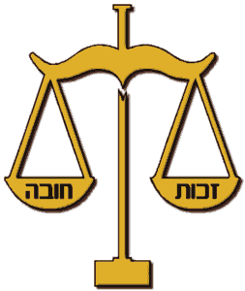

*In Ethics of the Fathers (chapter 4 Mishnah 22) it says ‘one minute of doing teshuva (repentance) in this world is better than all the bliss and happiness of the next world’. On Yom Kippur we have over 700 minutes (approx. 12 hours of davening time) of doing teshuva. Imagine how great that must feel. It also goes to show how great ‘teshuva’ is to be better than all the bliss of the next world!!!!!*



***What is ‘Teshuvah’?***

*Teshuvah (repentance) is made up of three parts: -*

1. *Acknowledge that a particular action was sinful, i.e. rioting.*
2. *Regret the sinful action and wish one had never done it.*
3. *Resolve that if one remained on this current lofty level achieved on Yom Kippur, you will not repeat this sin.*

*Our Rabbis tell us that when a person passes away all his actions and thoughts will be viewed by G-d and the heavenly angels. The embarrassment caused is how our rabbis explain the idea of ‘the fire of hell’. However, if one does proper teshuvah then those sinful actions will be erased from the video and no embarrassment will be caused. This should hopefully prompt us to make use of this wonderful gift that G-d has given us, and truthfully repent from our sins. Our Rabbis explain that the reason we repent 10 times over Yom Kippur is that hopefully one of those times will be sincere. In temple times the focal point of Yom Kippur was the service of the High Priest in the temple where he entered the Holy of Holies four times. As the temple no longer exists we recount the service word for word in the chazzan’s repetition of Mussaf. One should therefore make sure one is versed and alert when it comes to reading this in the synagogue.*

***The 5 special services on Yom Kippur***

***Kol Nidrei***

*This famous declaration of annulment of our vows is the way our rabbis chose to begin the Yom Kippur service. It is a way of showing how regret can make things better. After the Maariv davening we start Selichot. This is a series of prayers begging G-d for forgiveness. We also chant some wonderful, inspiring songs in which we declare our total inability to achieve anything without G-d’s help.*

***Shacharit***

*The theme of shacharit is G-d’s power in the world and his sovereignty. The extra prayers focus on the angelic praises of G-d.*

***Reading of the Law***

*The leining in the morning comes from where G-d tells Moses how and what service to perform on Yom Kippur in the temple. The Haftorah comes from Isiah who is telling the people that fasting is pointless if we continue in our evil ways, oppressing the poor and not generally caring about one another. We also read this in the Haforah for Shabbat Shuva ‘Tear your hearts not your clothes and return unto Hashem.’ (Joel chapter 2 verse 13)*

***Mussaf***

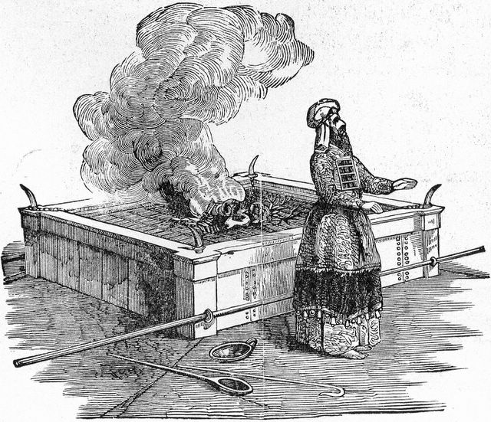

*In temple times the focal point of Yom Kippur was the service of the High Priest in the temple where he entered the Holy of Holies four times. As the temple no longer exists we recount the service word for word in the chazzan’s repetition of Mussaf. One should therefore make sure one is versed and alert when it comes to reading this in the synagogue.*

***Mincha***

*We read the chapter of forbidden relationships in order to warn people when they are all sitting together of the most severe sins. This also serves as a reminder that even though we are spiritually uplifted on Yom Kippur, we must guard against such sins. We also read the book of Yonah which shows the power of repentance where the whole city of Nineveh was saved.*

***Neilah***

*THIS IS THE HOLIEST TIME OF THE WHOLE HIGH HOLY DAY SEASON. Our rabbis tell us that G-d forgives the Jews approximately 15 minutes before the end of Yom Kippur. This corresponds to the time when the ‘He Goat’ containing all the Jews’ sins was pushed down the mountain in the temple times. (Please see further explanations of the ‘Yom Kippur Avodah’). After forgiveness has been issued one has a few minutes to pray for all one’s needs, which is why ‘Aveinu Malkeinu’ is recited even on Shabbos (we omit it at Kol nidrie and Shacharit ). We also declare our belief in G-d and his sovereignty in a holy, sin -free state. This has such a powerful effect in the lofty spheres. The time during Neilah is the most merciful time of the year. Both G-d and the Jews are emotional at the prospect of losing the close bond for another year. G-d also wants to bestow leaving presents to his dearest children. Even if one has been in a state of religious slumber and has not heeded any of the calls of the High Holy Days one can achieve forgiveness during Neilah.*

*A good example of this is the European Cup Final of 1999 between Manchester United and Bayern Munich. Entering injury time Bayern Munich were joyously celebrating their victory. Despite the impending doom United reinvigorated themselves and in a mere 99 seconds had snatched victory from the tonsils of defeat. This is how we can view Yom Kippur Neilah. Hope is never lost. Nothing is signed and sealed until the fat man blows the shofar!*

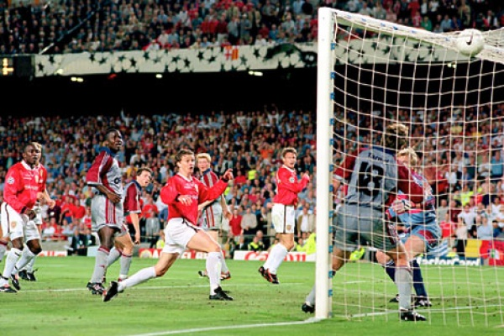

*At the end of the Bible Moses tells the Jews of the forthcoming exiles that the Jews will endure. The exile will only end when the Jews make one final sincere repentance. Let us hope that we can motivate ourselves, cast off the shackles of materialism and yearn for G- d’s salvation by doing a proper teshuvah. We wouldn’t want to be the ones that stopped the salvation from happening this year, Would we?*